**Assignment 3**

1. Write a SQL query to display those customers who are neither belongs to the city New York nor grade value is more than 100.

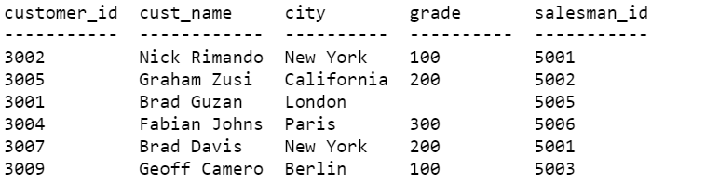

* Write a SQL statement which selects the highest grade for each of the cities of the customers.

1. Write a SQL statement to display either those orders which are not issued on date 2012-09-10 and issued by the salesman whose ID is 505 and below or those orders which purchase amount is 1000.00 and below.

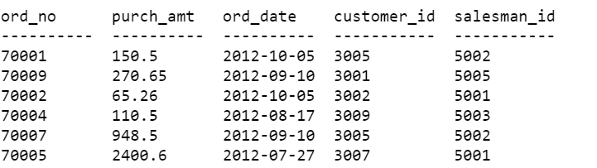

* Write a SQL statement to find the number of salesman currently listing for all of their customers.
* Write a SQL statement to know the maximum purchase amount of all the orders.
* Write a SQL statement to find the highest purchase amount ordered by the each customer with their ID and highest purchase amount.
* Write a SQL statement to find the highest purchase amount ordered by the each customer on a particular date with their ID, order date and highest purchase amount.
* Write a SQL statement to find the highest purchase amount on a date '2012-08-17' for each salesman with their ID.
* Write a SQL statement to find the highest purchase amount with their ID and order date, for only those customers who have highest purchase amount in a day is more than 2000.

(NOTE: you can use having clause)

1. Write a query in SQL to find the number of employees in each department along with the department code.

